Upload the Dataset

from google.colab import files
uploaded = files.upload()
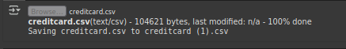

Load the Dataset

import pandas as pd
df = pd.read_csv('creditcard.csv')

Data Exploration

df.head()
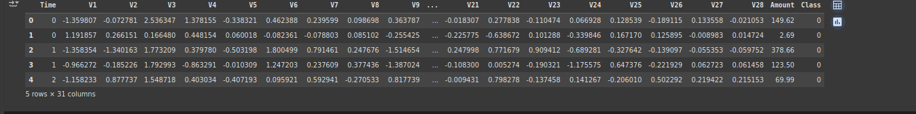
print("Shape:", df.shape)
print("Columns:", df.columns.tolist())
df.info()
df.describe()
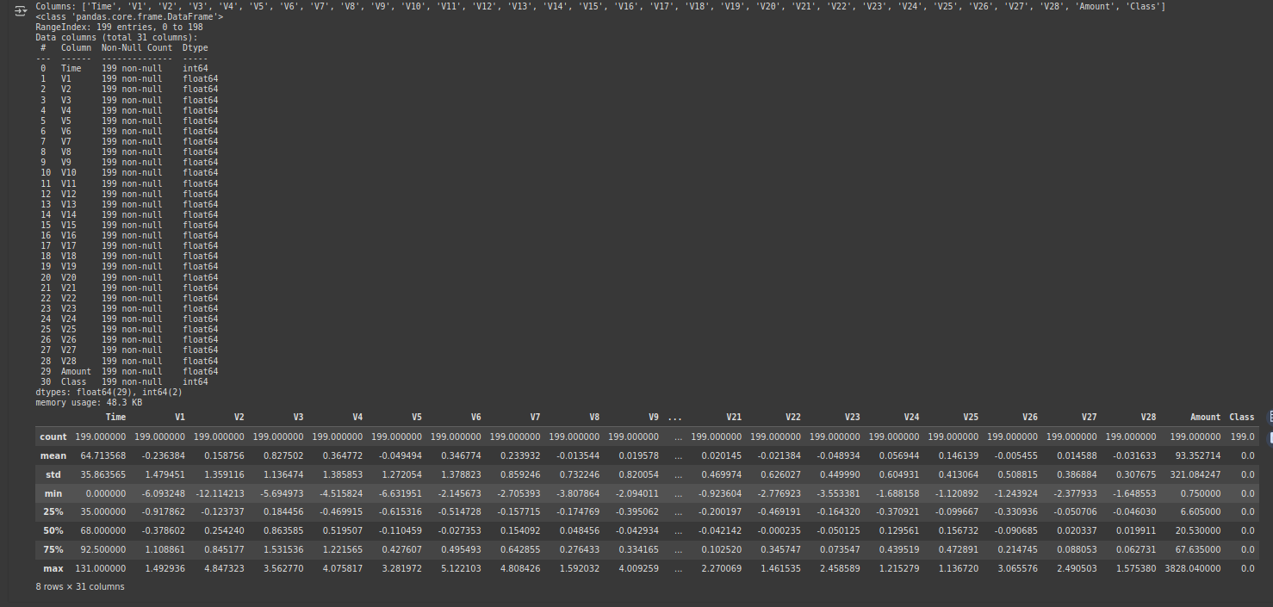

Check for Missing Values and Duplicates

print(df.isnull().sum())
print("Duplicate rows:", df.duplicated().sum())
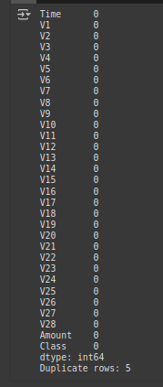

Visualize a Few Features

import seaborn as sns
import matplotlib.pyplot as plt
sns.countplot(x='Class', data=df)
plt.title("Fraudulent vs Non-Fraudulent Transactions")
plt.show()
fraud_ratio = df['Class'].value_counts(normalize=True).get(1, 0) * 100
print(f"Fraud Percentage: {fraud_ratio:.4f}%")
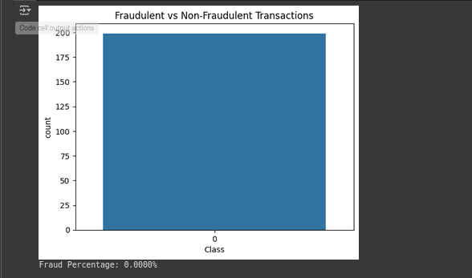
Feature Scaling

from sklearn.model_selection import train_test_split
from sklearn.preprocessing import StandardScaler
X = df.drop('Class', axis=1)
y = df['Class']
X['Amount'] = StandardScaler().fit_transform(X['Amount'].values.reshape(-1, 1))
X_train, X_test, y_train, y_test = train_test_split(X, y, test_size=0.2, random_state=42, stratify=y)

Model Building

from sklearn.model_selection import train_test_split
from sklearn.preprocessing import StandardScaler
X = df.drop('Class', axis=1)
y = df['Class']
X['Amount'] = StandardScaler().fit_transform(X['Amount'].values.reshape(-1, 1))
X_train, X_test, y_train, y_test = train_test_split(X, y, test_size=0.2, random_state=42, stratify=y)

Evaluation

from sklearn.metrics import classification_report, confusion_matrix, roc_auc_score
y_pred = model.predict(X_test)
print("Confusion Matrix:\n", confusion_matrix(y_test, y_pred))
print("\nClassification Report:\n", classification_report(y_test, y_pred))
print("ROC AUC Score:", roc_auc_score(y_test, y_pred))

Convert to DataFrame and Encode

def detect_transaction(input_data):
input_df = pd.DataFrame([input_data], columns=X.columns)
input_df['Amount'] = StandardScaler().fit_transform(input_df['Amount'].values.reshape(-1, 1))
prediction = model.predict(input_df)
return "Fraudulent" if prediction[0] == 1 else "Legitimate"

Predict the Final Grade

sample_input = X_test.iloc[0].tolist()
print("Prediction for transaction:", detect_transaction(sample_input))

Deployment-Building an Interactive App

!pip install gradio
